SCHOOL OF COMPUTER SCIENCE AND ARTIFICIAL INTELLIGENCE |  |  |  |  | DEPARTMENT OF COMPUTER SCIENCE ENGINEERING
Program Name: B. Tech |  |  |  | Assignment Type: Lab |  |  | Academic Year:2025-2026
Course Coordinator Name |  |  |  | Venkataramana Veeramsetty
Instructor(s) Name
  Dr. V. Venkataramana (Co-ordinator)
  Dr. T. Sampath Kumar
  Dr. Pramoda Patro
  Dr. Brij Kishor Tiwari
  Dr.J.Ravichander
  Dr. Mohammand Ali Shaik
  Dr. Anirodh Kumar
  Mr. S.Naresh Kumar
  Dr. RAJESH VELPULA
  Mr. Kundhan Kumar
  Ms. Ch.Rajitha
  Mr. M Prakash
  Mr. B.Raju
  Intern 1 (Dharma teja)
  Intern 2 (Sai Prasad)
  Intern 3 (Sowmya)
  NS_2 ( Mounika)
Course Code |  |  | 24CS002PC215 | Course Title |  | AI Assisted Coding
Year/Sem |  |  | II/I | Regulation |  | R24
Date and Day  of Assignment |  |  | Week5 - Monday | Time(s)
Duration |  |  | 2 Hours | Applicable to  Batches
AssignmentNumber: 9.1(Present assignment number)/24(Total number of assignments)
NAME: P. HEMAN ROLL NO: 2403A510F5
BATCH:06 DATE: 08-09-2025
 | Q.No. | Question |  |  |  |  |  | Expected Time  to complete
 | 1 | Lab 9 – Documentation Generation: Automatic Documentation and Code Comments  Lab Objectives  - To use AI-assisted coding tools for generating Python documentation and code comments.  - To apply zero-shot, few-shot, and context-based prompt engineering for documentation creation.  - To practice generating and refining docstrings, inline comments, and module-level documentation.  - To compare outputs from different prompting styles for quality analysis.  Task Description #1 (Documentation – Google-Style Docstrings for Python Functions)  - Task: Use AI to add Google-style docstrings to all functions in a given Python script.  - Instructions:  - Prompt AI to generate docstrings without providing any input-output examples.  - Ensure each docstring includes:  - Function description  - Parameters with type hints  - Return values with type hints  - Example usage  - Review the generated docstrings for accuracy and formatting.  - Expected Output #1:  - A Python script with all functions documented using correctly formatted Google-style docstrings.  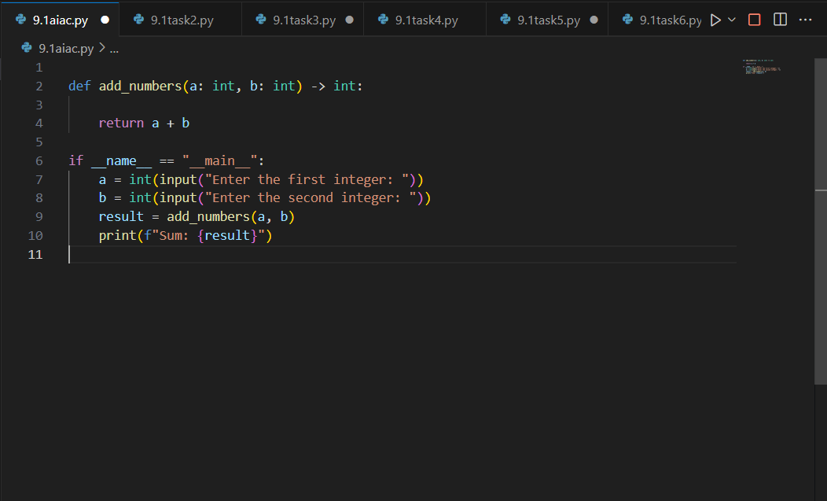  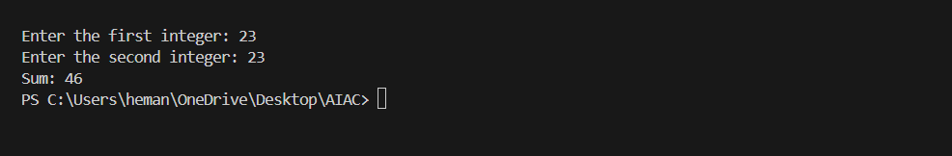  Task Description #2 (Documentation – Inline Comments for Complex Logic)  - Task: Use AI to add meaningful inline comments to a Python program explaining only complex logic parts.  - Instructions:  - Provide a Python script without comments to the AI.  - Instruct AI to skip obvious syntax explanations and focus only on tricky or non-intuitive code sections.  - Verify that comments improve code readability and maintainability.  - Expected Output #2:  - Python code with concise, context-aware inline comments for complex logic blocks.  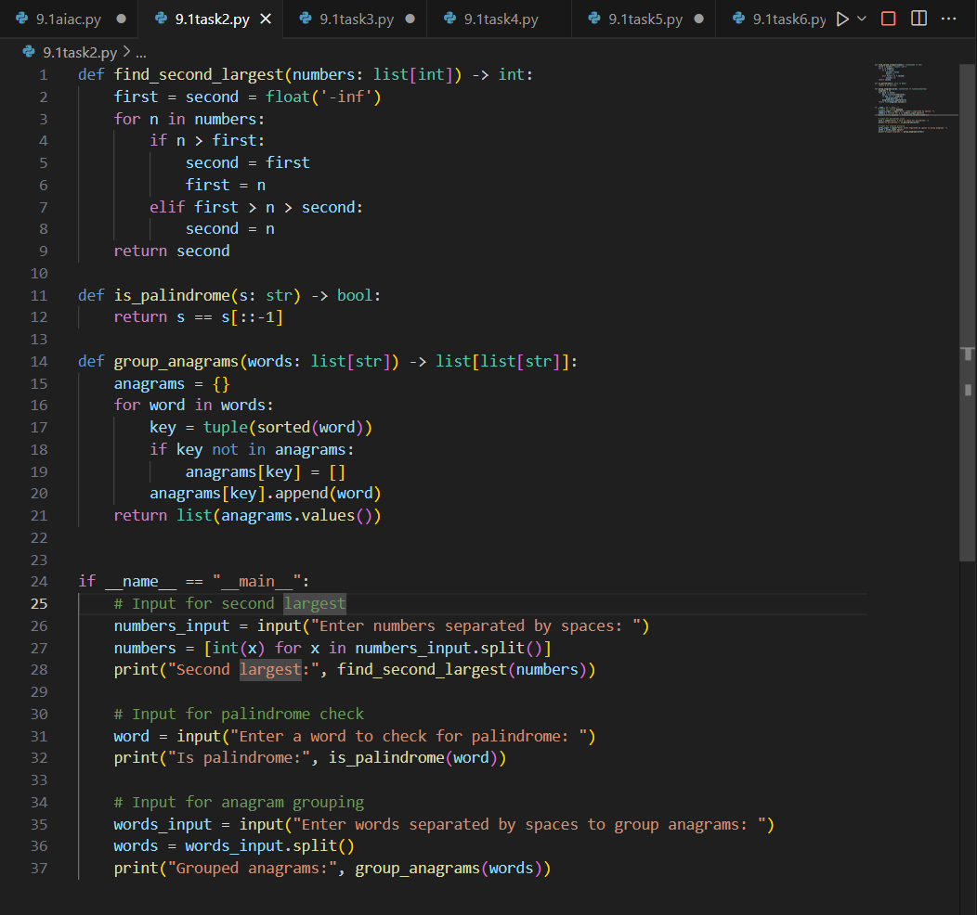  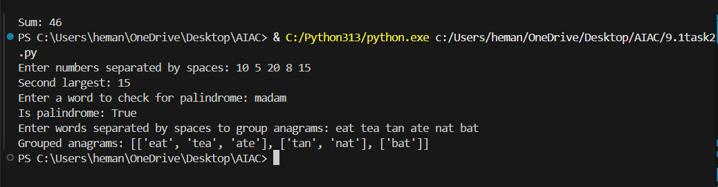  Task Description #3 (Documentation – Module-Level Documentation)  - Task: Use AI to create a module-level docstring summarizing the purpose, dependencies, and main functions/classes of a Python file.  - Instructions:  - Supply the entire Python file to AI.  - Instruct AI to write a single multi-line docstring at the top of the file.  - Ensure the docstring clearly describes functionality and usage without rewriting the entire code.  - Expected Output #3:  - A complete, clear, and concise module-level docstring at the beginning of the file.  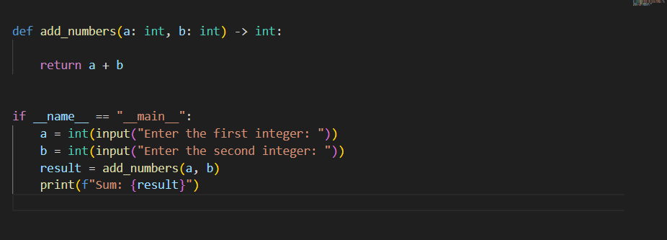  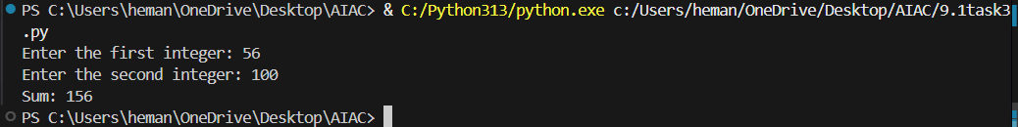  Task Description #4 (Documentation – Convert Comments to Structured Docstrings)  - Task: Use AI to transform existing inline comments into structured function docstrings following Google style.  - Instructions:  - Provide AI with Python code containing inline comments.  - Ask AI to move relevant details from comments into function docstrings.  - Verify that the new docstrings keep the meaning intact while improving structure.  - Expected Output #4:  - Python code with comments replaced by clear, standardized docstrings.  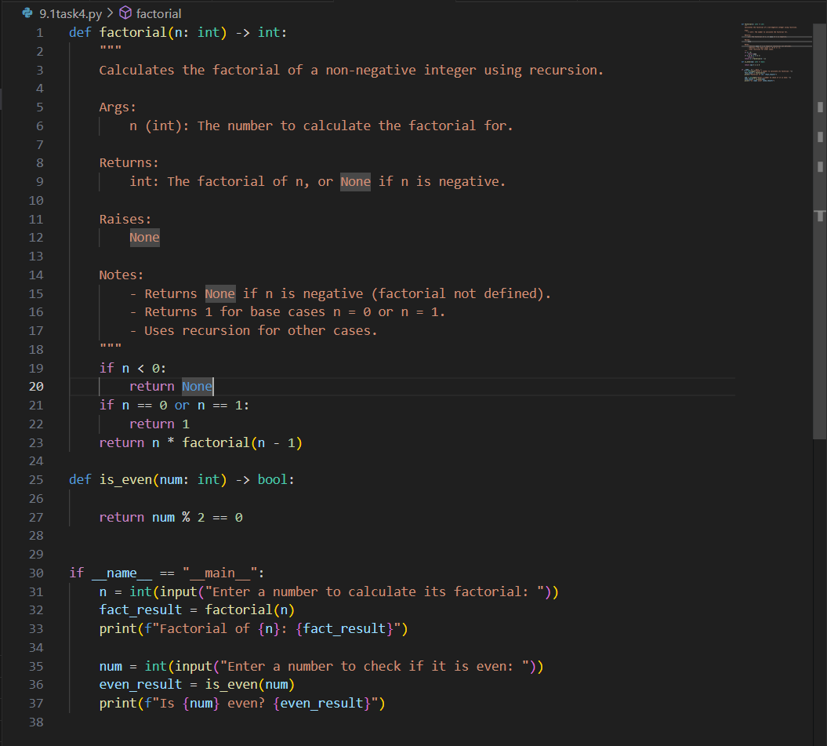  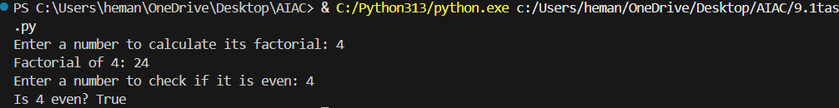  Task Description #5 (Documentation – Review and Correct Docstrings)  - Task: Use AI to identify and correct inaccuracies in existing docstrings.  - Instructions:  - Provide Python code with outdated or incorrect docstrings.  - Instruct AI to rewrite each docstring to match the current code behavior.  - Ensure corrections follow Google-style formatting.  - Expected Output #5:  - Python file with updated, accurate, and standardized docstrings.  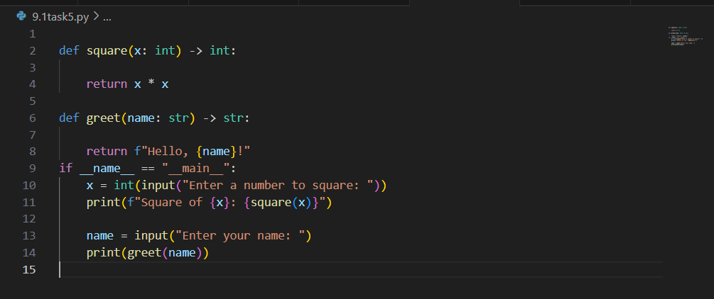  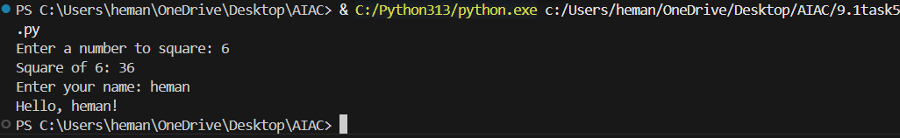  Task Description #6 (Documentation – Prompt Comparison Experiment)  - Task: Compare documentation output from a vague prompt and a detailed prompt for the same Python function.  - Instructions:  - Create two prompts: one simple (“Add comments to this function”) and one detailed (“Add Google-style docstrings with parameters, return types, and examples”).  - Use AI to process the same Python function with both prompts.  - Analyze and record differences in quality, accuracy, and completeness.  - Expected Output #6:  - A comparison table showing the results from both prompts with observations.  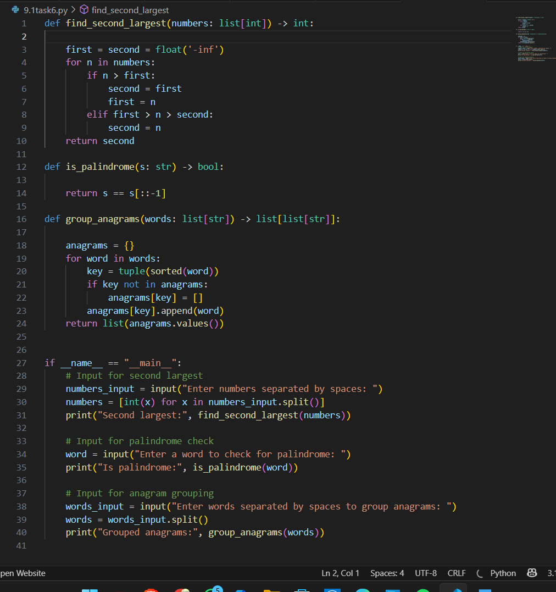  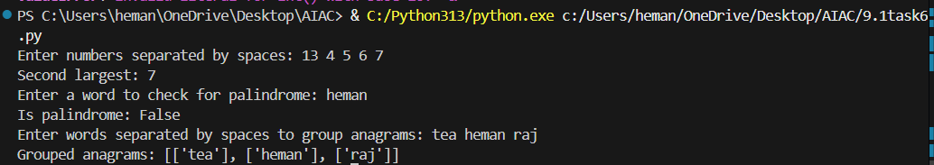 |  |  |  |  |  | Week5 - Monday

